# Climate change is real.

**Are you tired of weather swings occurring in your local area?**

**Do you want a safer and cleaner planet to live on?**

**Do you want your generation to be safe from destruction?**

**Then Say No to Climate Change.**

Climate change is the cause of increased natural disasters, weather swings, rising of sea level, extinction of animals and pollution of the atmosphere due to carbon emissions. But we can stop it by

1. Saying NO to Carbon Emission vehicles and switching to electric cars. 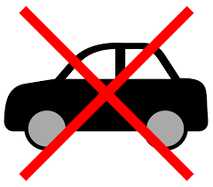 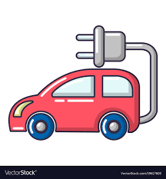

2. Recycling - Why dispose when you can make 5$ per bottle when you recycle and make the atmosphere cleaner because by recycling we would reduce greenhouse gases emitted during production of these products.

** **

3. Making use of public transportation - The use of public transportation such as buses, trains, also walking, cycling, skating and carpooling would help limit the amount of cars on the road. The limiting of these carbon cars would reduce carbon emission in the atmosphere. .

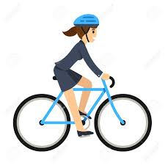

**LETs SAVE THE PLANET BECAUSE IT’S OURS TO SAVE.**